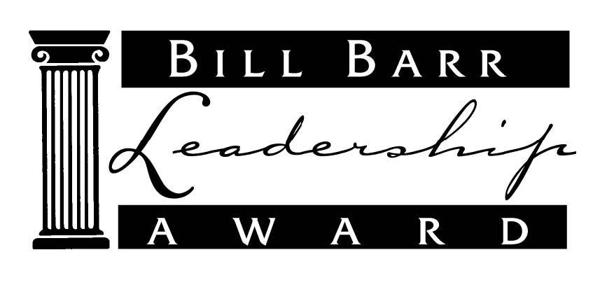

TO HONOR THOSE

EXCEPTIONAL SUPERINTENDENTS

WHO POSSESS THE UNIQUE ABILITY

TO MENTOR,

TO TEACH AND

TO LEAD OTHERS

IN PURSUING EXCELLENCE

IN PUBLIC EDUCATION.



Bill Barr Leadership Award

**Purpose of the Award**

Quality leadership involves the ability to teach and mentor others. From the start of his career in education to his role as Executive Director of GSSA, Bill Barr has done just that. Look anywhere in Georgia education and you will see graduates of Bill Barr’s courses in school finance in addition to numbers of educators mentored by him in countless areas. It was in recognition of these contributions that the Bill Barr Leadership Award was established. Any active member of the Georgia School Superintendents Association is eligible to nominate a Georgia superintendent.

**Eligibility**

A superintendent eligible for this award:

• Currently serves as a Georgia public school superintendent; and,

• Has served as a school superintendent for at least five years prior to the current year of service; and, is a

• Current member of GSSA with demonstrated association program involvement.

**Criteria**

In order to nominate a superintendent for this award, the nominator must describe demonstrated leadership professionally and personally. This should include:

1. A *specific example* of the nominee’s leadership in teaching/mentoring other superintendents or those aspiring to the superintendency.

2. Demonstrated leadership in his/her own school district in a manner that has had impact on students, teachers, school system, parents, community, etc. Example: curriculum and instruction, fiscal management, personnel management, etc.

**Nomination Process**

The nomination form is emailed to all active superintendents and RESA Directors. The nomination form must be submitted to the GSSA office **on or before September** **15, 2023**, to be considered.

**Presentation of Award**

The presentation of the 2023 Bill Barr Leadership Award will take place at the 2023 Fall Bootstrap Conference.

GSSA Bill Barr Leadership Award

2023 Official Nomination Form

THIS FORM CAN BE PHOTOCOPIED. All applications must be received no later than September 15, 2023. Failure to complete all portions of this form will result in disqualifica­tion. Only GSSA Superintendent Members are eligible for nomination. The form may be scanned and emailed to [jzauner@gssaweb.com](mailto:jzauner@gssaweb.com) or mail the completed form to:

**GSSA**

**9 Jefferson Street**

**Newnan, GA**

For questions, please call (678) 857-3642.

Superintendent Nominee’s Name____________________________________________________

School System___________________________________________________________________

Address___________________________________ City______________________ Zip________

Years as a public-school superintendent (through 2022 - 2023) _________ years

Vita attached yes no

Describe a *specific example* of this superintendent’s leadership in which his/her teaching/mentoring skills have been central.

________________________________________________________________________________

________________________________________________________________________________

________________________________________________________________________________

________________________________________________________________________________

________________________________________________________________________________

________________________________________________________________________________

Provide at least one **example** of this superintendent’s leadership within his/her district, including the positive effect that this has had on students, teachers, parents, community, school system, etc.

________________________________________________________________________________

________________________________________________________________________________

________________________________________________________________________________

________________________________________________________________________________

________________________________________________________________________________

***This form is valid only for the 2023 Bill Barr Leadership Award Program.***